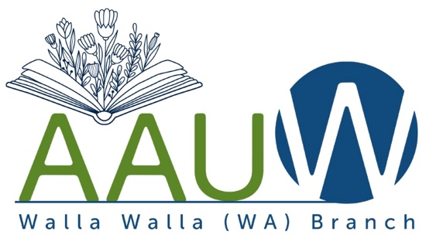
2024 Community Mini-Grant Application

Our mission:
Advocating equity, education, and opportunities for local women and girls to achieve their full potential.

AAUW-Walla Walla raises funds for women’s scholarships and community projects. Required criteria to be considered for a Community Mini-Grant are:

- Projects must be in Walla Walla County or Milton-Freewater.
- Projects must address our mission.
- Projects must provide visibility for the AAUW-Walla Walla branch.

Application deadline: 5:00 p.m. on Monday, April 15, 2024
The Community Mini-Grant Committee submits funding recommendations to the AAUW-Walla Walla Board within 30 days of the stated deadline.

Organization Name:

Contact Person:

Mailing Address:

Email:

Phone:

Amount Requested:

Specific details of the proposed project, addressing all three project criteria stated in this document’s introduction above:

Goals and objectives for the proposal:

Description of the target population and perceived need:

Project implementation timeline:

Details of the proposed budget for these funds:

Description of how impact and success will be measured and documented, including plan for a written wrap-up report:

Description of how AAUW-WW’s participation and support will be recognized:

List of additional stakeholders, community partners, and/or funding sources, if any:

To submit electronically via email: send to Susan Greene at greene.song@gmail.com. If you have additional documents you wish to include with your application, please attach them to your submission email.

Documents may also be mailed to AAUW-Walla Walla, P.O. Box 12, Walla Walla, WA 99362 (postmarked by April 15, 2024).

If you have questions, please contact Susan Greene by email or phone (916-947-3096).

